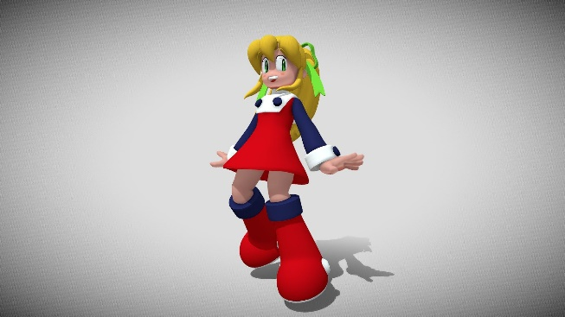

[This Photo](https://sketchfab.com/3d-models/roll-rockmanmegaman-fan-art-e48a5830454b41698f50bf4e4c690d58) by Unknown Author is licensed under [CC BY](https://creativecommons.org/licenses/by/3.0/)

***Game Framework***

***Lora Chisholm***

***Jeremiah Pineda***

***CSE 310 – Applied Programming***

***Module Submit***

1. Copy the link to your public GitHub repository here:

<https://github.com/lachisholm/Arcade.git>

1. Mark an “X” next to the module you completed:

|  |  |  |  |
| --- | --- | --- | --- |
| **Cloud Databases** |  | **Language – Java** |  |
| **Data Analysis** |  | **Language – Kotlin** |  |
| **Game Framework** | X  2-D game framework | **Language – R** |  |
| **GIS Mapping** |  | **Language – Erlang** |  |
| **Mobile App** |  | **Language – JavaScript** |  |
| **Networking** |  | **Language – C#** |  |
| **Web Apps** |  | **Language – TypeScript** |  |
| **Language – C++** |  | **Language – Rust** |  |
| **SQL Relational Databases** |  | **Choose Your Own Adventure** |  |

1. Complete the following checklist to make sure you completed all parts of the module. Mark your response with “Yes” or “No”. If the answer is “No” then additionally describe what was preventing you from completing this step.

|  |  |
| --- | --- |
| **Question** | **Your Response** |
| Did you implement the entire set of unique requirements as described in the Module Description document in I-Learn? | This is a simple 2D platformer with basic game mechanics and a physics engine. If there were additional features of the game such as levels, enemies, special effects have not yet been implemented. But the framework is complete as per requirements. |
| Did you write at least 100 lines of code in your software and include useful comments? | The code is over 100 lines |
| Did you use the correct README.md template from the Module Description document in I-Learn? | Yes, I used the template and went back through instructions a couple times |
| Did you completely populate the README.md template? | Yes, I did the entire read me to cover the aspects of the game framework. |
| Did you create the video, publish it on YouTube, and reference it in the README.md file? | Yes I did a video, and put it where the teacher instructed |
| Did you publish the code with the README.md (in the top-level folder) into a public GitHub repository? | Yes I published and upload to the GitHub repository |

1. If you completed a stretch challenge, describe what you completed.

The stretch I completed was adding new level and multiple coins to the game framework.

1. How many hours did you spend on this module this Sprint? Include all time including planning, researching, implementation, troubleshooting, documentation, video production, and publishing.

Planning: 1 hour

Researching: 1 hour

Downloads: 30 mins

Implementation: 1 to 2 hours

Troubleshooting: over 4 hours

Documentation: 40 mins

Video: 3- to 40 mins – setup, dress, and record properly

Publishing: 10 mins

1. What learning strategies worked well in this module and what strategies (or lack of strategy) did not work well? How can you improve in the next module?

The biggest hindering I had was to keep referring back to multiple documents to align requirements. It would help if the requirements were all on one page. I felt I couldn’t get to creative of my own because of the “requirements”. I have a pretty creative mind and if given a list of parameters for turning in and then letting me do the rest, I can get something pretty good done with time and freedom.

I like producing games, and I think I have a lot to learn moving forward in my learning and ability to produce them.